#### 1. BMW 4 Series Convertible

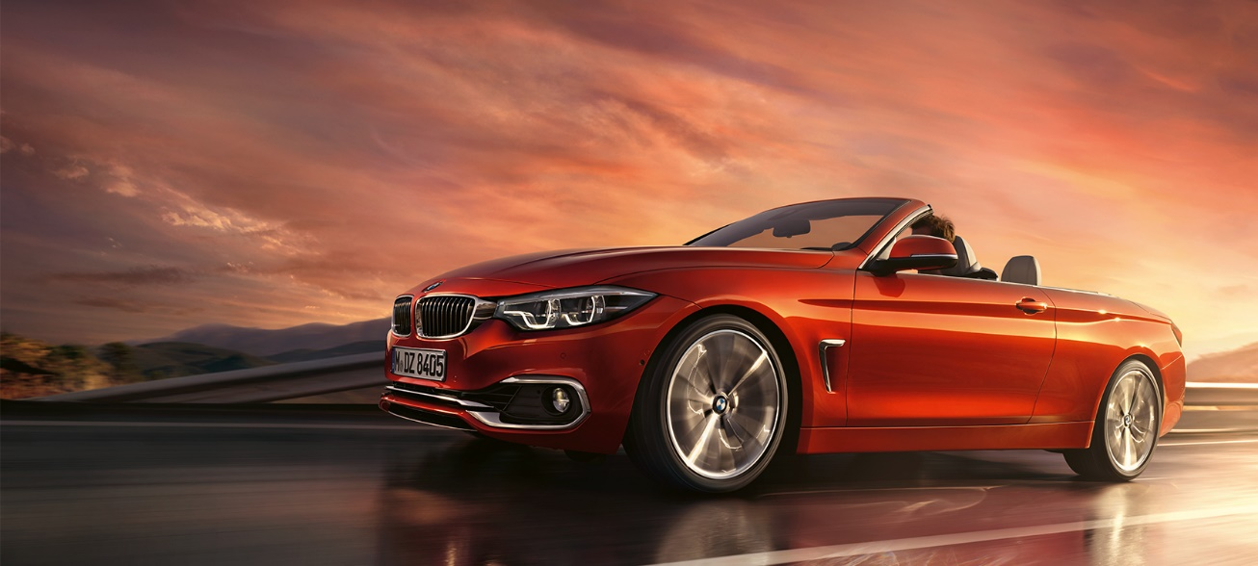

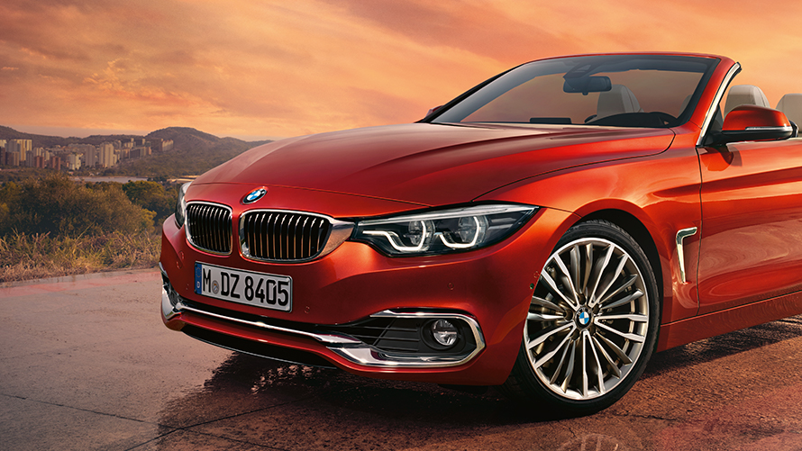

The BMW 4 Series Convertible: Catch the sun, feel the wind and savour those special driving moments. With sporty agility and stirring dynamics – accompanied by an impressive, aerodynamic design and stylish equipment with plenty of innovative functionalities. The ultimate contemporary defines freedom on four wheels.

|  |  |
| --- | --- |
| Basic model from | 3,929,000 THB |
| Acceleration 0-100 km/h in s | 6.3 |
| Maximum speed in km/h | 250 |
| Combined consumption in Km/l | 15.6 |
| CO2 emission in g/km | 147 |
| Open the top in seconds (BMW 430i Convertible) | approx. 20 sec |

#### 2. BMW 8 Series Coupé THE8

# 2019 BMW 8 Series an expensive proposition at $111,900

Impressive down to the last thread. While outstanding paint finishes bring out the appearance of the BMW 8 Series Coupé, luxurious materials with stylish contrast stitchings and classy decorative elements enhance the sporty interior – imbuing it with a particularly high-quality look. This is especially emphasized in the positioned perforations and special quilting of the optional multi-functional seats. Combining top performance with the highest quality and creating an extremely sporty and elegant ambience in the interior.

#### https://www.bmw.co.th/content/dam/bmw/common/all-models/8-series/coupe/2018/at-a-glance/bmw-8series-coupe-aesthetics-th-desktop-02.jpg

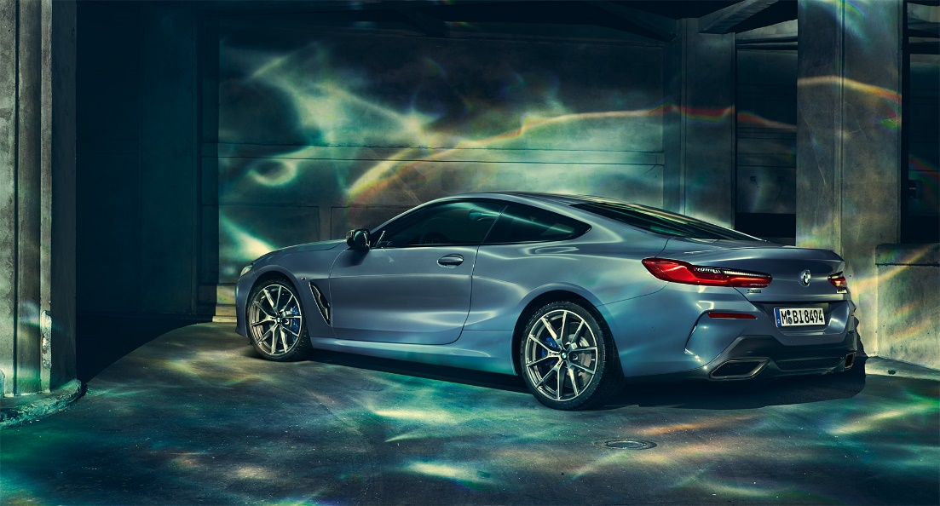

| Weight |
| --- |
| Unladen weight EU in kg | 1,965 |
| Max. permissible weight in kg | 2,395 |
| Permitted load in kg | 505 |
| Permitted axle load front/rear in kg | 1,235-1,250 |
| Luggage capacity in l | 420 |
| Trailer load 8% (braked) in kg | - |

| Engine |
| --- |
| Cylinders/valves | 8/4 |
| Capacity in ccm | 4,395 |
| Stroke/bore in mm | 88.3/89.0 |
| Engine power in kW (PS) at 1/min | 390 (530)/5,500-6,000 |
| Engine torque (Nm) at 1/min | 750/1,800-4,600 |
| Compression ratio : 1 | 10.5 |

| Performance |
| --- |
| Top speed in km/h | 250 |
| Acceleration 0–100 km/h in s | 3.7 |

#### 3.BMW 7 Series Sedan

#### The BMW Group has a long tradition of creating the automotive future. We believe the best way to predict the future is to create it. With the BMW 7 Series we are creating tomorrow’s luxury today. Thanks to game-changing innovations, benchmarking comfort and contemporary design as well as dynamics that are both impressive and highly efficient.

#### https://www.bmw.co.th/content/dam/bmw/common/all-models/7-series/sedan/2015/at-a-glance/g11g12_ataglance-stage.jpg.asset.1489136912793.jpg

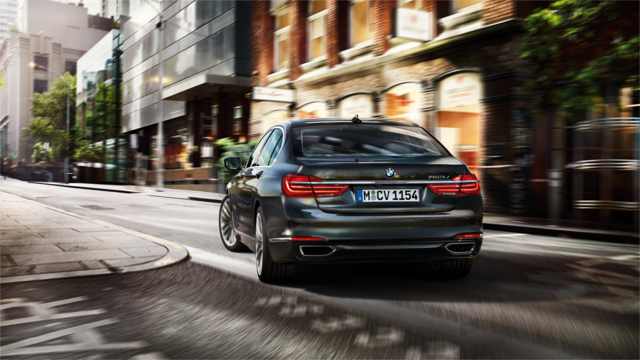

|  |  |
| --- | --- |
| Basic Model from | 5,799,000 Baht |
| Max. output in kW (hp) at 1/min (730d) | 195 (265)/4,000 |
| CO2 emissions in g/km (730d) | 129–119 |
| Combined in l/100 km (730d) | 4.9–4.5 |
| Top speed in km/h (730d) | 250 |

#### 4. BMW X1

The BMW X1 breaks new ground instead of following established routines. From the very first glance, it shows that it is an X model through and through: the short overhangs and long wheelbase typical of an SAV (Sports Activity Vehicle) define its exterior. Inside, too, the X philosophy is consistently maintained. Surrounded by high-quality materials and an intuitive operating concept, the BMW X1 treats its passengers to an elevated seating position. And the interior is not only extremely welcoming but also exceptionally variable. At the same time, the efficient and dynamic petrol and diesel engines with BMW EfficientDynamics technologies whet your appetite for the next stage.

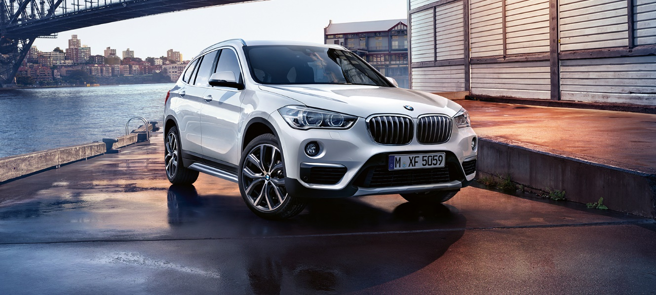

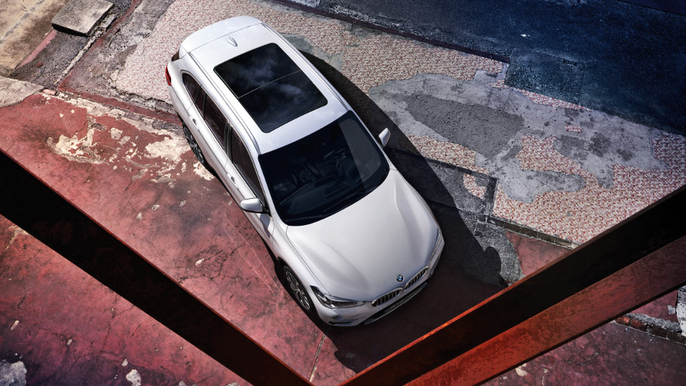

|  |  |
| --- | --- |
| Basic Model from | 2,329,000 baht |
| Max. output (kW/hp/rpm) | 100/136/4,500-6,000 |
| Max. torque (Nm/rpm) | 220/1,250-4,000 |
| CO2 emissions (g/km) | 118.0 |
| Combined consumption (km/l) | 20.0 |

#### 5. BMW M2 Competition

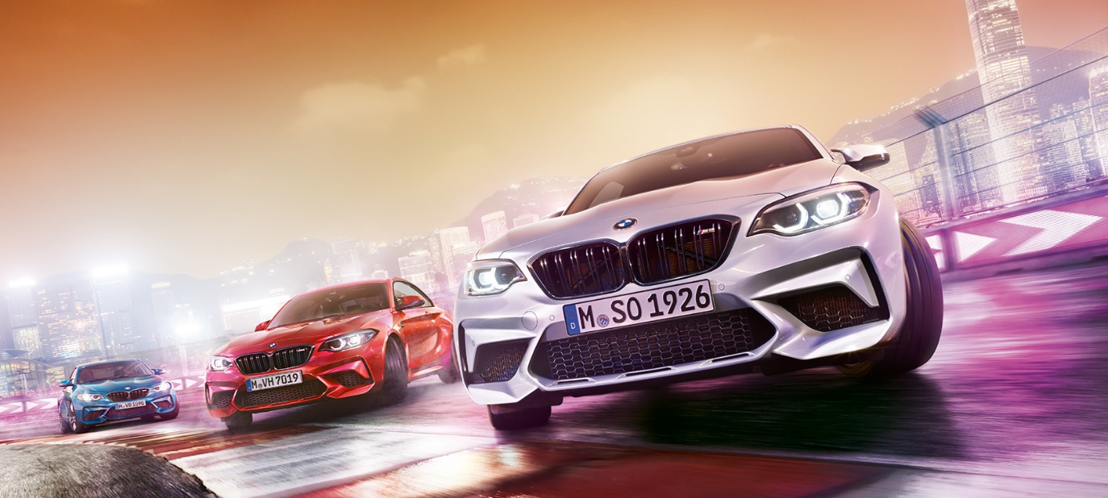

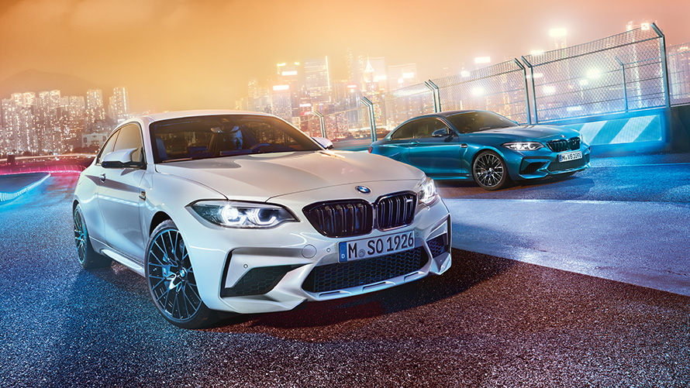

A sports car that changes every road. The BMW M2 Competition overwhelms with an outstanding combination of performance, agility and precision. The enlarged air inlets in the front apron signal the concentrated power of the new 410 hp Bi-turbo inline 6-cylinder petrol engine. The BMW M2 Competition is a permanent guarantee of high performance and the aspiration to set new records. A genuine M automobile, built for winners.

|  |  |
| --- | --- |
| Basic model from | 6,259,000 THB |
| Combined consumption in km/l | 11.5 |

CO2 emissions in g/km (combined) 227 – 224

# **5 TOP FACTS**

* 01Weight-optimised Bi-turbo for maximum power delivery
* 02Output 302 kW (410 hp)
* 03Maximum torque 550 Nm*
* 04From 0 to 100 km/h in 4.2 s with M DCT*
* 05Maximum engine speed 7,600 rpm*

#### 6. BMW i8

An entirely new concept of sports car. More efficient – for example due to intelligent lightweight construction with carbon and aerodynamic design. More sustainable – with highly efficient BMW eDrive technology and recyclable materials in the interior. Without forfeiting dynamics and its sporting appearance. No compromises, but instead the optimum combination of driving pleasure and responsibility. The BMW i8 is a plug-in-hybrid that brings together the advantages of innovate electric motor and combustion engine technologies. The result is an extraordinary driving experience – with extremely low consumption and low emissions.

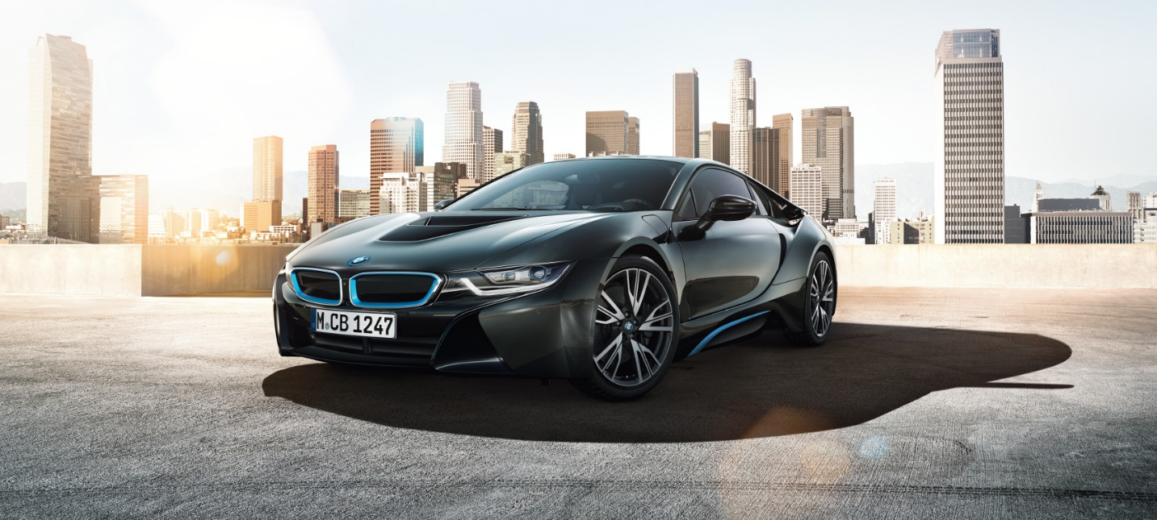

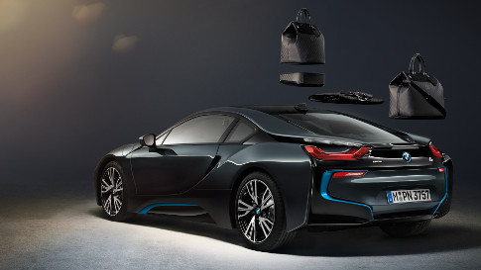

|  |  |
| --- | --- |
| Basic Model from | 11,799,000 THB |
| Acceleration from 0–100 km/h (seconds) | 4.4 |
| Combined consumption (km/l) | 47.6 |
| CO2 emissions (g/km) | 49.0 |
| Electric range (km) | 37 |

#### 7. BMW i8 Roadster

#### The future is taking shape – in the form of the first ever BMW i8 Roadster. Enthusiastic, fascinating and ready to reinterpret freedom. For unconditional driving pleasure, as far as the road goes. From the first glimpse of the iconic design adrenaline levels rise. The tachometer shoots up just as fast: the innovative plug-in hybrid engine generates 374 hp and 570 Nm and accelerates the BMW i8 Roadster from 0 to 100 km/ h in just 4.6 seconds. The fastest route to experience a new form of freedom.

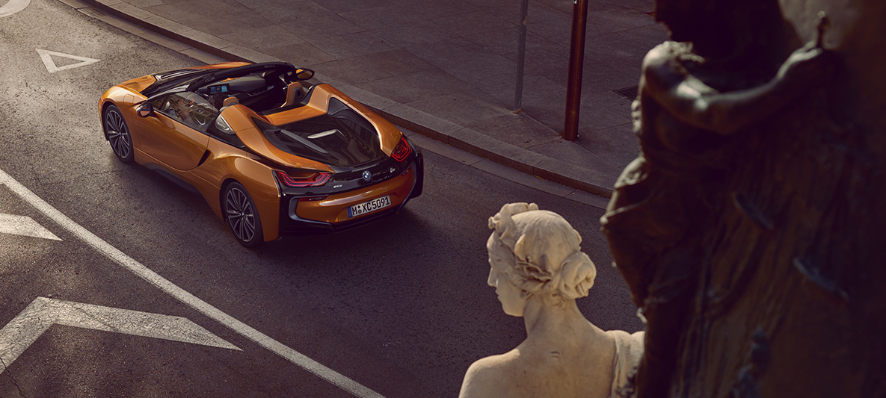

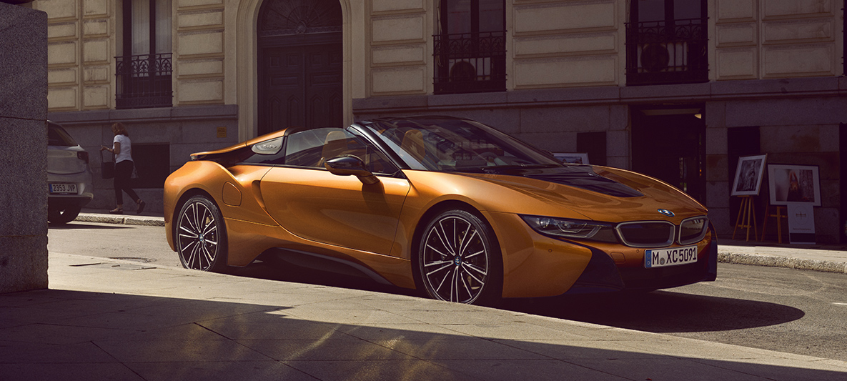

|  |  |
| --- | --- |
| Basic model from | 12,959,000 THB |
| Consumption |
| **CO2 emissions combined in g/km** | **51.0** |
| **Consumption combined in l/100 km** | **2.1** |
| Drive |
| **Internal combustion engine: Cylinders/valves** | **3/4** |
| **Internal combustion engine: Stroke/bore in mm** | **94.6/82.0** |
| **Internal combustion engine: max. output in kW (hp) at 1/min** | **170 (231)/5,800-6,000** |
| **Internal combustion engine: max. torque in Nm at 1/min** | **320/3,700** |

| Performance |
| --- |
| **Maximum speed on purely electric power in km/h** | **120.0** |
| **Maximum speed in km/h** | **250.0** |
| **Acceleration from 0–100 km/h in seconds** | **4.6** |

#### 8. BMW 5 Series Touring

#### Outstanding driving dynamics, sporty design, maximum comfort – the BMW 5 Series Touring is a true master of its class. Equipped with cutting-edge technology, maximum functionality and a large portion of sporting flair. A versatile all-rounder that offers plenty of space for all manner of activities. And a guarantee of driving pleasure that raises leisure and business to a new level.

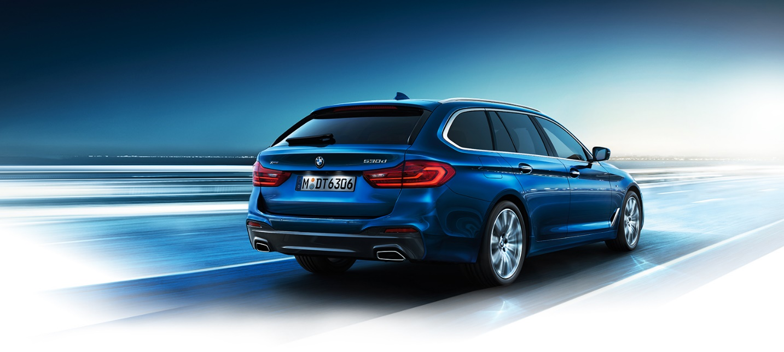

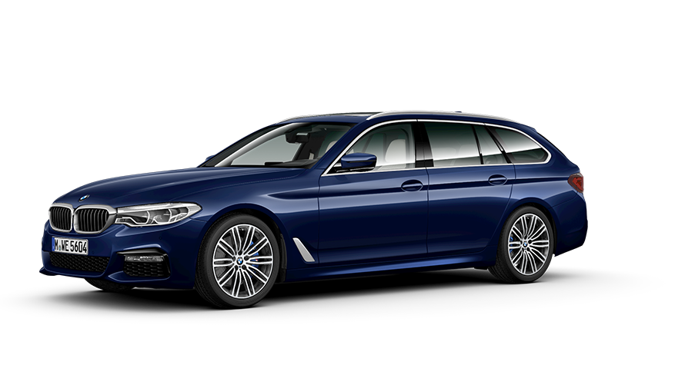

|  |  |
| --- | --- |
| Basic model from | 4,499,000 THB |
| Acceleration 0-100 km/h in s (BMW 530i Touring) | 6.5 |
| Consumption in l/100 km, combined (BMW 530i Touring) | 6.3–5.8 |
| CO2 emission in g/km, combined (BMW 530i Touring) | 143–133 |

#### 9. BMW X6

Powerful and athletic. With the presence of an X model and the sportiness of a coupé, the BMW X6 transcends all limits. Its BMW TwinPower Turbo engines are a potent mixture of dynamics and efficiency, and BMW xDrive helps to bring this power to the street. Outstanding equipment such as the Design Pure Extravagance package as well as top-quality materials characterise a vehicle that is sure to take centre stage – and, at the same time, is astonishingly functional.

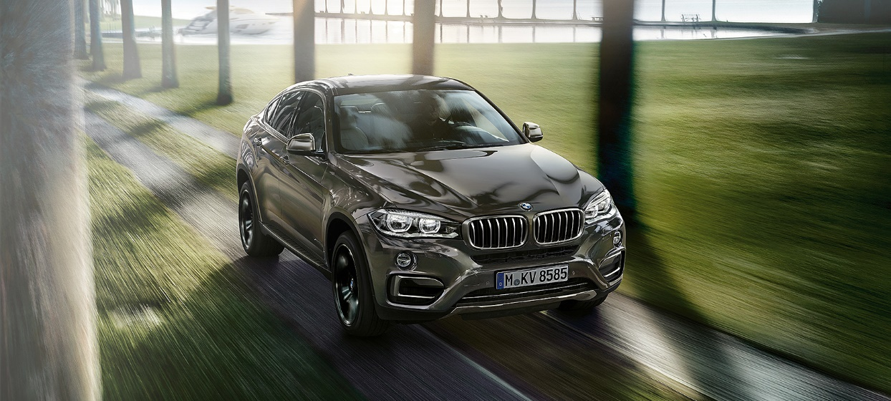

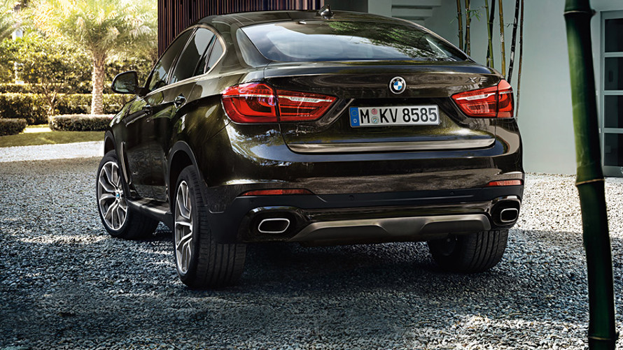

|  |  |
| --- | --- |
| Basic Model from | 6,939,000 baht |
| Max. output (kW/hp/rpm) | 160/218/4,000 |
| Acceleration 0–100 km/h (s) | 7.7 |
| Top speed in km/h (50i) | 250 |
| Luggage compartment capacity in litres (50i) | 580-1,525 |